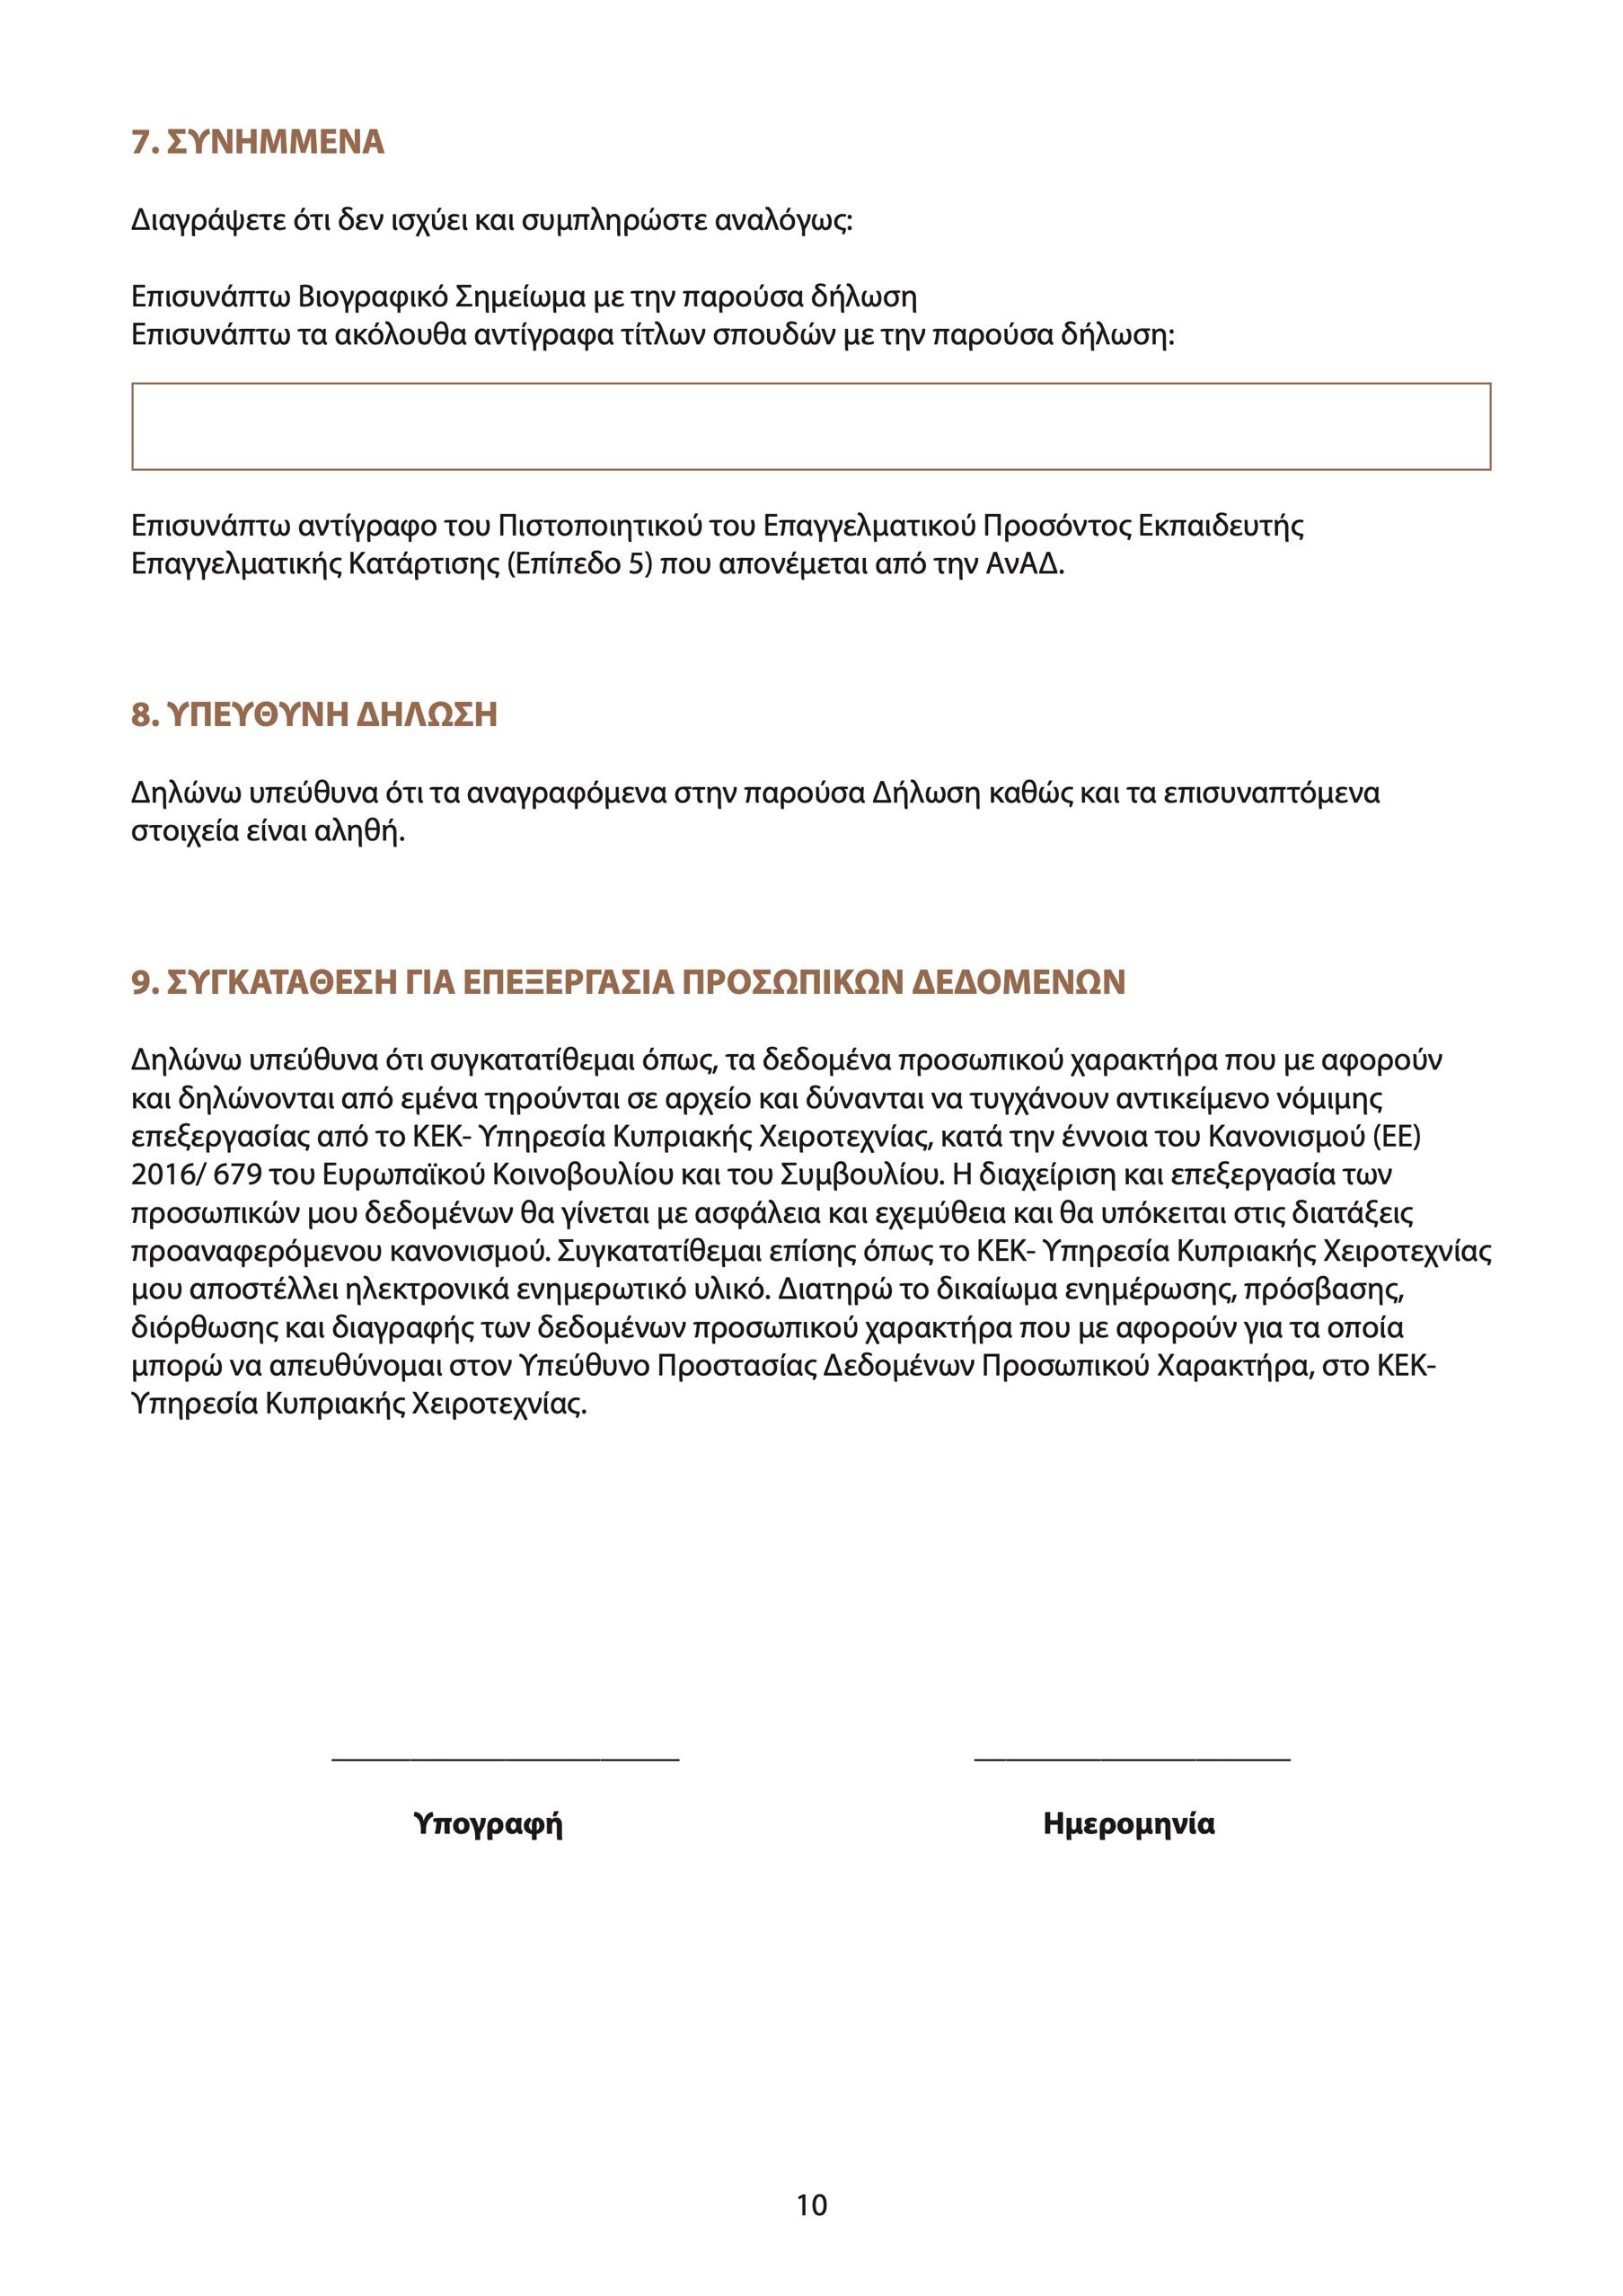

00/00/2022